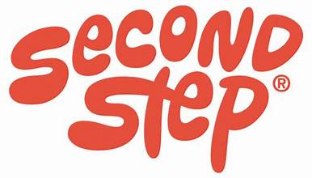
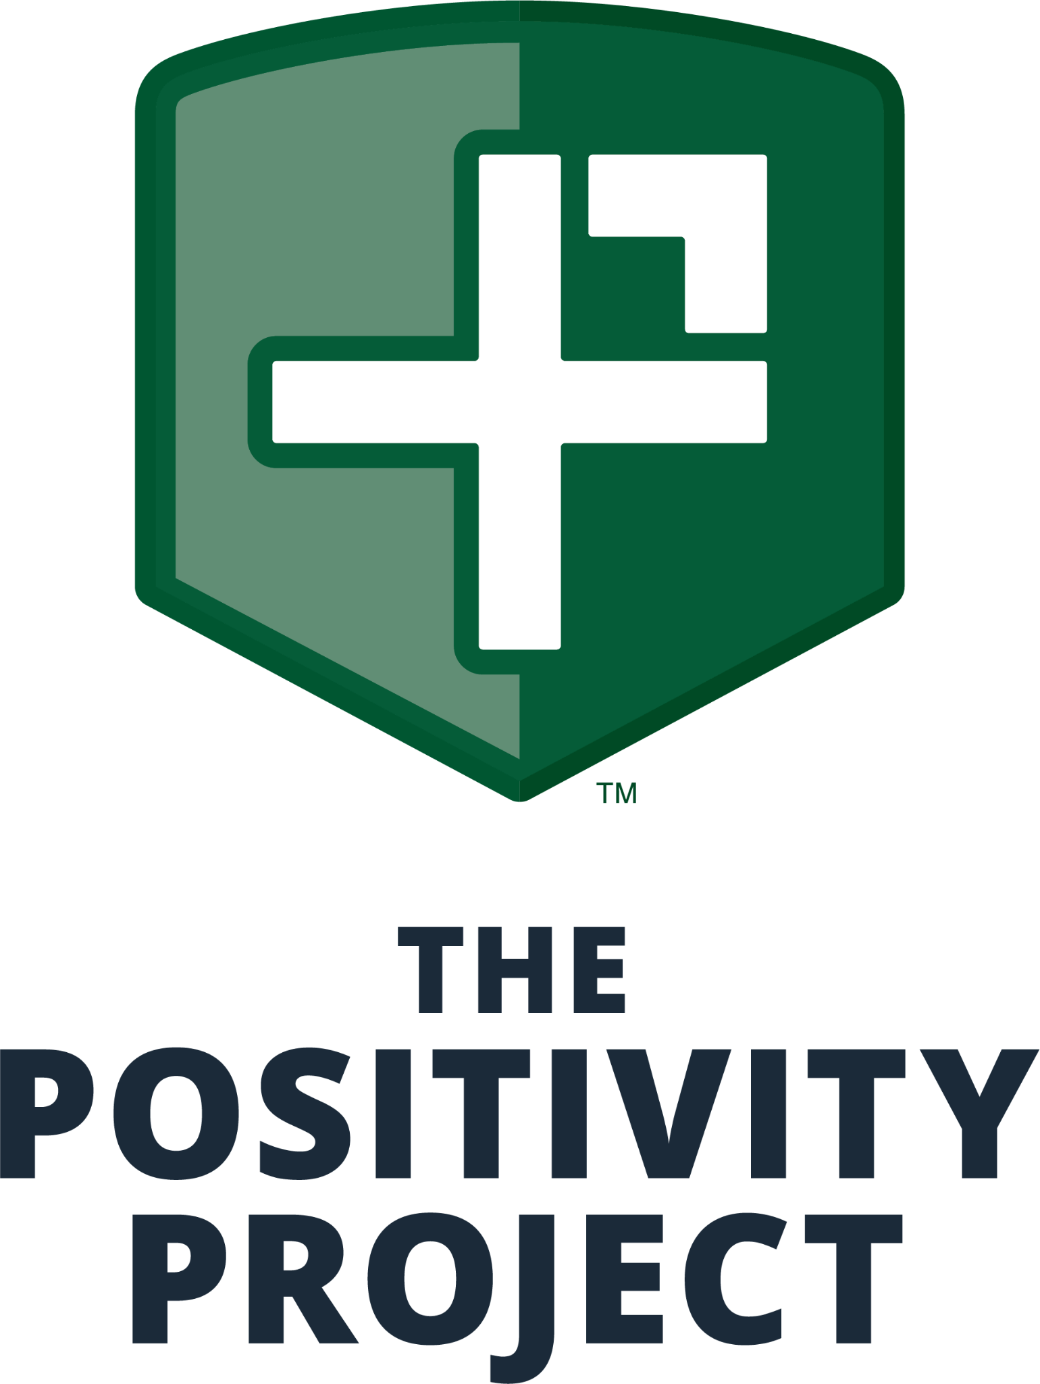
SEL Schedule
Positivity Project
Character Strengths Calendar 2025-2026

SEL Schedule
Positivity Project | Second Step
Monday - Thursday | Friday
Positivity Project |  | Second Step
DATES | Character Strength / Other People Mindset | Implementation Schedule
August 25th-29th | Building Class Culture/PACK Expectations
September 2nd-5th | PACK Expectations/Zones of Regulation
September 8th-12th | Introduction to P2
September 15th-19th | Curiosity | 9/19: Unit 1, Lesson 1
September 22nd-26th | Teamwork | 9/26: Unit 1, Lesson 2
September 26th | Wear Olds shirt or colors for curiosity and teamwork
September 29th-  October 3rd | Open-Mindedness
October 6th | World Day of Bullying Prevention-Wear Blue
October 6th-10th | OPM: Being present and giving others my attention | 10/10: Unit 1, Lesson 3
October 13th-17th | Integrity
October 22nd | Wear Orange for National Unity day for Bullying prevention
October 21st-24th | Creativity | 10/24: Unit 1, Lesson 4
October 24th | Wear school colors to celebrate: Open-mindedness, OPM:Being present and giving others my attention, and Creativity.
October 27th-31st | Bullying Prevention SPIRIT WEEK!!
October 27th-31st | OPM: Knowing my words and actions affect others
November 3rd-7th | Bravery | 11/7: Unit 1, Lesson 5
November 10th-14th | Spiral Review
November 13th | World Kindness Day-Wear your favorite color.
November 17th-28th | Gratitude | 11/21: Unit 2, Lesson 6
Nov. 21st | Wear school colors for OPM: Knowing my words and actions affect others, Bravery, and Gratitude!!
December 1st-5th | Kindness | 12/5: Unit 2, Lesson 7
December 8th-12th | OPM: Supporting others when they struggle | 12/12: Unit 2, Lesson 8
December 15th-19th | Holiday SPIRIT WEEK
December 15th-19th | Self-Control | 12/19: Unit 2, Lesson 9
Dec. 22nd-January 4th | Winter Break
January 5th-9th | P2 Review/PACK Expectations
January 12th-16th | Optimism | 1/16: Unit 2, Lesson 10
January 20th-23rd | Prudence
January 27th-30th | Perseverance | 1/30: Unit 3, Lesson 11
January 30th | Wear BLUE for Optimism, Prudence, and Perseverance.
February 2nd-6th | Forgiveness
February 9th-13th | Love | 2/13: Unit 3, Lesson 12
February 17th-20th | OPM: Cheering others’ success
February 23rd-27th | Humility | 2/27: Unit 3, Lesson 13
February 27th | Wear school colors or Forgiveness, Love, Cheerleading others successes, and humility.
March 2nd-6th | Love of learning | 3/6: Unit 3, Lesson 14
March 9th-13th | Perspective
March 16th-19th | OPM: Identifying and appreciating the good in others | 3/19: Unit 3, Lesson 15
March 23rd-27th | Social Intelligence
March 27th | Wear school colors for love of learning, Perspective, and Identifying and appreciating the good in others, and social intelligence.
March 30th--April 6th | SPRING BREAK
April 7th-10th | Humor | 4/10: Unit 4, Lesson 16
April 13th-17th | Fairness
April 20th-24th | Appreciation of beauty and excellence | 4/24: Unit 4, Lesson 17
April 27th-30th | Purpose
April 30th | Wear school colors for Humor, Fairness, Appreciation of beauty and excellence, and purpose
May 4th-8th | Enthusiasm | 5/8 :Unit 4, Lesson 18
May 11th-15th | Leadership | 5/15: Unit 4, Lesson 19
May 18th-22nd | Spiral Review | 5/22 :Unit 4, Lesson 20
May 26th-29th | Outro Week
May 29th | Wear school Colors for Enthusiasm, Leadership, and P2 review.
Last two weeks of school | Closure for the year, more details to come

